20BCE1837

EX No. 12

Date: 2.11.2022

1. **Aim**

To work on NodeJS and MongoDB

1. **Installing NodeJS**
   1. **Procedure**
      1. Download Node.js installer from [http://nodejs.org](http://nodejs.org/)
      2. Node.js installer installs the necessary files on your PC to get Node.js up and running
      3. Node.js installation location
      4. To verify whether Node.js is installed and working execute the command “node” in command prompt

**OUTPUT:**

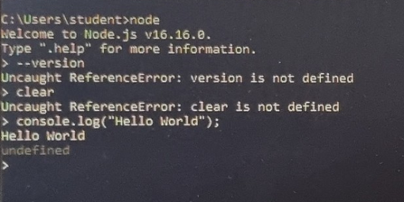

# Installing MongoDB

## Procedure

* + 1. Download MongoDB installer from [http://mongodb.com](http://mongodb.com/)
    2. The installer installs the necessary files on your PC to get MongoDB up and running
    3. In the folder C :¿ Program Files ¿ MongoDB, create 2 Folders
    4. Name first folder as data, Name other folder as log
    5. Create another folder inside ’data’ and name it as db. Data stored here
    6. To configure Mongodb, you can type - mongod --directoryperdb -- dbpath C:>Program Files>MongoDB>data>db --logpath C>Program Files>MongoDB>log>mongo.log --logappend --rest --install

To verify whether MongoDB is installed and working execute the command “mongo” in command prompt

**OUTPUT:**

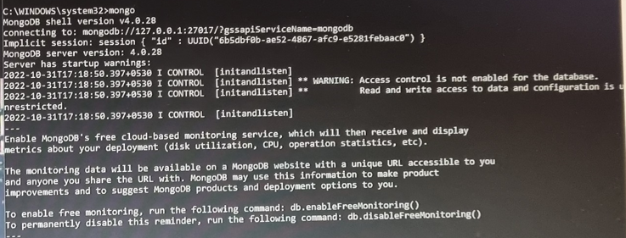

Results:

Thus NodeJS and MongoDB have been introduced